***Business Reason***

***Task Requirements***

* Email Signature Format
  + <Rep First Name> <Rep Last Name>  (include space between names)
  + <Phone>
  + <Email>
* Which E-mails are we talking about?
  + Approval E-mails?
  + Transition Notifications
    - Finalize (in quote finalized step)
      * No e-mail template is a body text with Smart Tags
    - Email Documents action
      * PrintCSA (XSL Printer Friendly)

***Build Plan***

1. For Finalize e-mails:
   1. Quote Finalized step, all participant profiles, Finalize action, the Finalize Contract: to Contract Finalized transition rule, Define Notifications

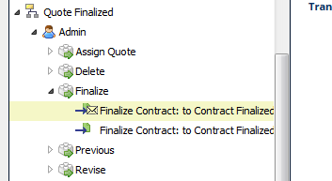

* 1. Change the body so it looks like this:

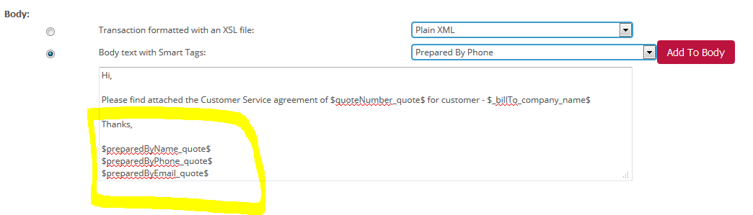

* 1. Save the notification
  2. Save the transition rule
  3. Deploy Commerce

1. For Email Documents action
   1. Print CSA printer friendly 🡪 CSA (CSA_bmDocEdClone_1) Document in Doc Engine
   2. I found 2 signatures:
      1. Cover Page

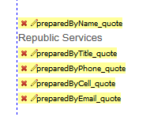

* + 1. Proposal Line Items

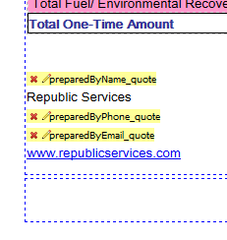

1. We need to confirm that they want to change the Doc Engine signatures, we will confirm this during today’s call.

***Admin Guide Changes***

***User Guide Changes***